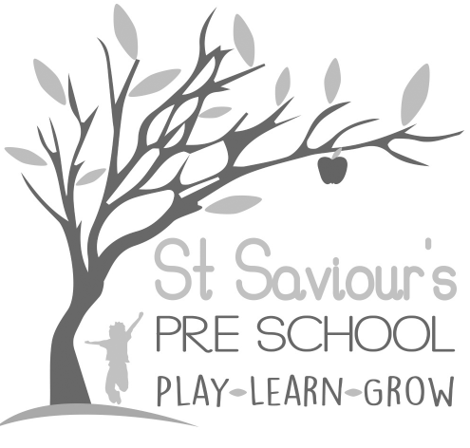
7.2 PHYSICAL CONTACT AND PHYSICAL HANDLING POLICY

Written by: Claire Toms and Tina Alder Date: 1.09.22 – reviewed 28.8.25

Policy Statement
Children at St Saviour’s Pre-school and Nursery need to form close bonds with key persons to develop confidence, emotional security, and wellbeing.
There are occasions when children require cuddles, encouragement, holding, or other forms of physical reassurance. Intimate care and physical reassurance routines are essential to meet children’s basic needs, support secure attachment, and promote emotional development.
Whilst being mindful of safeguarding, child protection requirements, and hygiene, we believe friendly, appropriate physical contact is central to warm, personal relationships and the provision of high-quality care for young children.
Early Years Practitioners are responsible for promoting the emotional development of children, based on secure attachment and a sense of safety, in line with EYFS 2025.

Procedures

Comforting Children
- If a child requires comforting due to an accident, upset, or separation from a parent, cuddles or physical reassurance may be given, ensuring consent and willingness of the child where possible.
- When children are separating from a parent, practitioners may physically support the transfer to the key person with the parent’s consent.
- Children may sit on an adult’s lap only if it provides comfort, helps the child settle, and the child agrees or asks for it.
- Picking up a child may occur as a last resort to prevent self-harm, harm to others, or to support inclusion in a group activity.
- Staff will explain to children why some forms of physical contact instigated by the child are not appropriate (e.g., kissing).

Physical Contact in Play
- Appropriate physical contact during play—such as piggybacks, catching children in games, or supporting them in physical activities—is acceptable if the child willingly participates.
- Staff follow TAB guidelines on physical contact, ensuring interactions are safe, supportive, and respectful.

Physical Handling in Behaviour Management
- In line with our Behaviour Management Policy, staff support children to take responsibility for their own behaviour through:
  - Positive role-modelling
  - Planning challenging and engaging activities
  - Setting developmentally appropriate boundaries and expectations
  - Providing positive feedback and encouragement
- Positive handling or restraint is only used to prevent harm or de-escalate a situation, kept to a minimum, and carried out by staff trained in TAB physical intervention techniques.
- All incidents of physical handling are recorded in the Incident Book, including details of the event, actions taken, staff involved, and notified to parents on the same day.

Safeguarding Considerations
- All intimate care and physical contact is delivered in line with EYFS 2025 safeguarding and welfare requirements.
- Staff must be mindful of individual children’s comfort, consent, and personal boundaries, ensuring all interactions are appropriate and professionally conducted.
- Any concerns about inappropriate contact or safeguarding issues must be reported immediately to the manager and follow the Setting’s Safeguarding Policy.

This policy reflects:
- EYFS 2025 emphasis on emotional security, secure attachment, and safeguarding
- Herts County Council TAB guidance on positive handling, de-escalation, and consent
- Clear procedures for comfort, play, behaviour management, and safeguarding

